SOCIAL MEDIA TOOLKIT

Midwifery for Consumers: #ConsiderMidwifery
Call to Action
The term “midwife,” (mid-wife) originates from old English, meaning with woman. Midwives are health care providers that provide care during pregnancy, childbirth, and the postpartum period—and also provide reproductive and primary health care at every life stage, including routine gynecologic care, annual exams, family planning services, and contraception education. Midwives use the midwifery model of care, which is a philosophy that views pregnancy and childbirth as normal life events and emphasizes person-centered care.
Although midwives are an essential part of the health care workforce, their work is often misunderstood, underused, and undervalued. The United States has the highest maternal mortality rates of any high-income country. In New Jersey, a Black woman is seven times more likely to die of pregnancy or birth issues than a white woman, and a Black baby is three times more likely than a white baby to die before their first birthday. In most of the higher income countries with better maternal health outcomes, midwifery-led care is the norm. Here in New Jersey, midwives have a key role in eliminating the state’s intolerable disparities.
This toolkit provides education and sample social media posts to raise consumers’ awareness on the importance of midwifery care to all families. Since birthing people can choose from a range of maternity care providers, midwives must be considered amongst their options. Our goal is to emphasize the benefits of midwifery care and relay that all consumers should consider choosing a midwife as their care provider.
Guiding Principles: This toolkit aims to serve as a resource that provides education about the midwifery profession. This toolkit should be used with the intention of raising awarness, gaining and providing knowledge, and increasing advocacy towards the field.

Instructions: This toolkit contains key messages, social media posts, graphics, and an email/newsletter text that promotes midwifery messaging for consumers. Please share this content through your social media platforms and tag the New Jersey Health Care Quality Institute and the Burke Foundation in your advocacy efforts to support and expand access to midwifery. You may also include your own social media handles, graphics, and hashtags as you customize each message to your liking.
Key Messages for Consumers

• What is a Midwife: Midwives are health care clinicians who provide expert care for you throughout pregnancy, childbirth, and postpartum—but their care isn't limited to just that. From teenage years to adulthood, they provide a range of services like annual check-ups, reproductive health care, family planning, and more. Whether in hospitals, clinics, birth centers or at home, midwives specialize in low-risk pregnancies, ensuring you receive personalized, expert care every step of the way.
• The Midwifery Approach: Midwives follow a unique philosophy centered around your needs. They see pregnancy and childbirth as natural processes and prioritize your involvement and education. With a focus on respect and shared decision-making, midwives aim to minimize medical interventions while providing culturally sensitive care tailored to you. It's all about supporting you to be empowered to make informed choices about your health.
• Advantages of Midwifery Care: Studies reveal that choosing midwifery care can lead to better outcomes for both you and your baby. From reduced rates of cesarean sections to increased breastfeeding success, midwifery care addresses your physical, social, and emotional well-being. By emphasizing education and prevention, midwives ensure you receive top-notch care that respects your autonomy and preferences.
• Your Right to Choose Midwifery Care: Your health care experiences, including your birth experience, should reflect your wishes and values. With midwifery care, you can build a close relationship with your caregiver and receive holistic, personalized support. Every consumer deserves the option to choose midwifery care, and policies should ensure equal access for all.
• Understanding the Differences between Midwives and Obstetricians (OB/GYN): While both midwives and obstetricians provide excellent care, there are differences in the models of care they use. Midwives excel in health, wellness, and individualized care, while obstetricians’ strengths are in managing complications and medical interventions. Midwives specialize in low-risk pregnancies and vaginal birth, while obstetricians handle a wider range of cases and perform surgical deliveries. By working together, midwives and obstetricians can ensure the best possible outcomes for you and your baby.

Social Media Campaign
Handles:
- Twitter & Facebook:
  - @NJHCQI
  - @BurkeFoundation
- LinkedIn:
  - @New Jersey Health Care Quality Institute
  - @The Burke Foundation
- Instagram:
  - @the_quality_institute_nj

Hashtags (If you would like to include):
#ConsiderMidwifery, #MidwivesMakeADifference, #MidwivesMatter, #MaternalHealth, #MidwiferyCare #BirthJourney #Midwifery #Midwife #Midwives #MidwifeServices #Pregnancy #Labor #Births #NewJersey #NJ #ReproductiveHealth #WomensHealth
Website to Drive Traffic:
https://njhcqi.info/MIHHub

This social media kit contains sample posts you can easily customize, as well as images for you to include in your posts.

- Curious about the safety of midwifery care? Research shows that midwives provide safe, evidence-based care with excellent outcomes for birthing people and babies. With their expertise and personalized approach, midwives prioritize your health and well-being throughout your pregnancy journey. Consider midwifery care for a safe and empowering birth experience! #ConsiderMidwifery
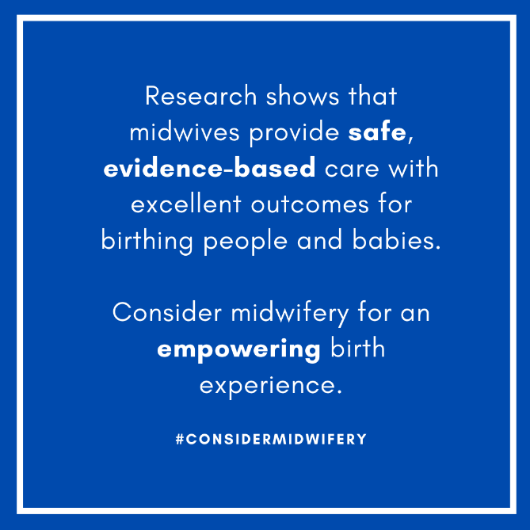

- Did you know midwives aren't just for pregnancy? They offer comprehensive care for every stage of life! From family planning, well-woman care, to menopause—they’ve got you covered. #ConsiderMidwifery
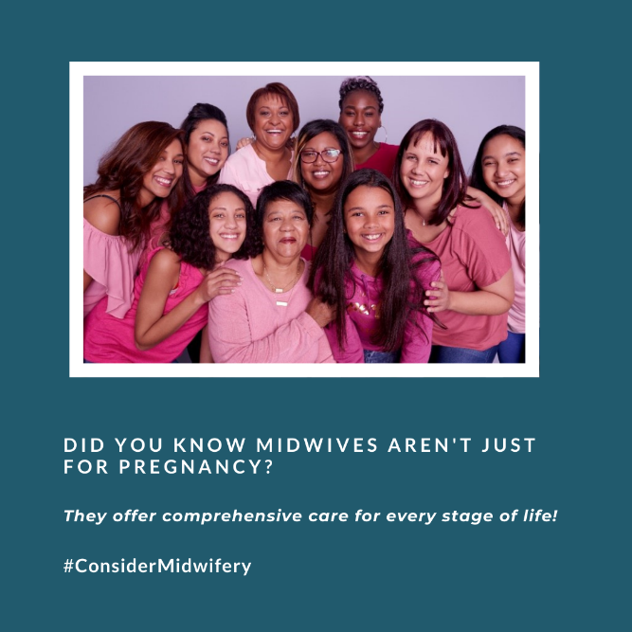

- Looking for a care provider who listens and supports your choices? Consider a midwife! They provide compassionate care and prioritize your well-being every step of the way. #ConsiderMidwifery #MidwivesMakeADifference #MidwivesMatter
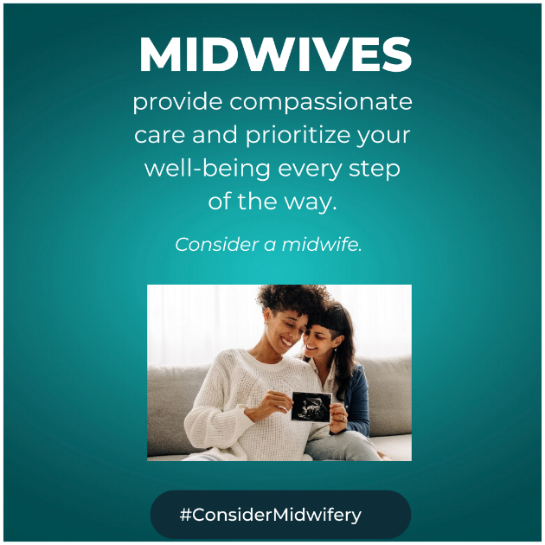

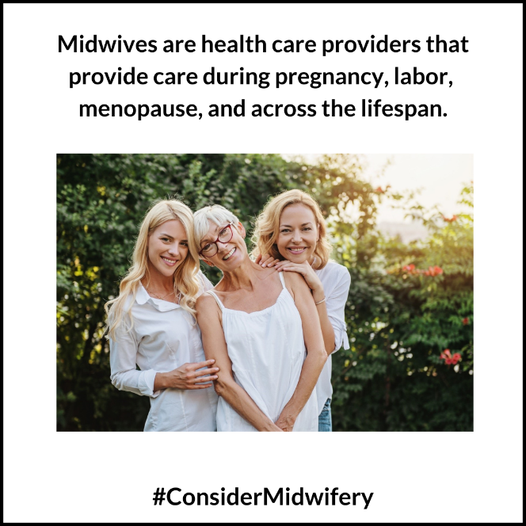
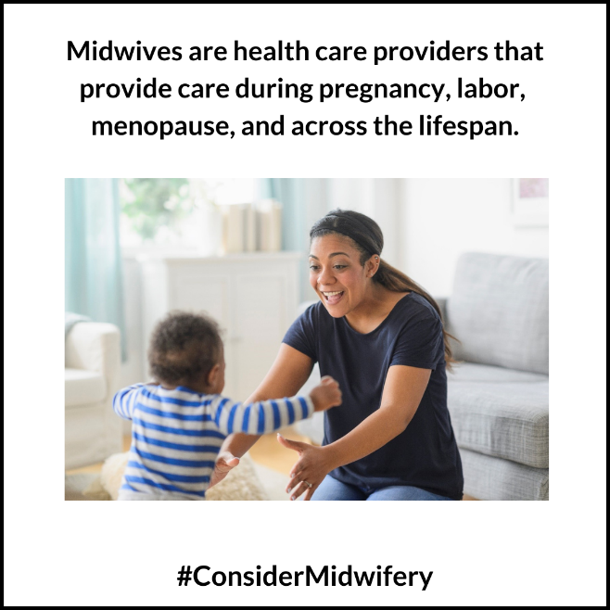
- Midwives are health care providers that provide care during pregnancy, labor, menopause, and across the lifespan. Beyond pregnancy, they provide essential services including primary care, family planning, reproductive health care, gynecological visits, and more. Learn more about the benefits of midwifery to make an informed choice about your care! #ConsiderMidwifery #MidwiferyCare #MaternalHealth #ReproductiveHealth #Healthcare

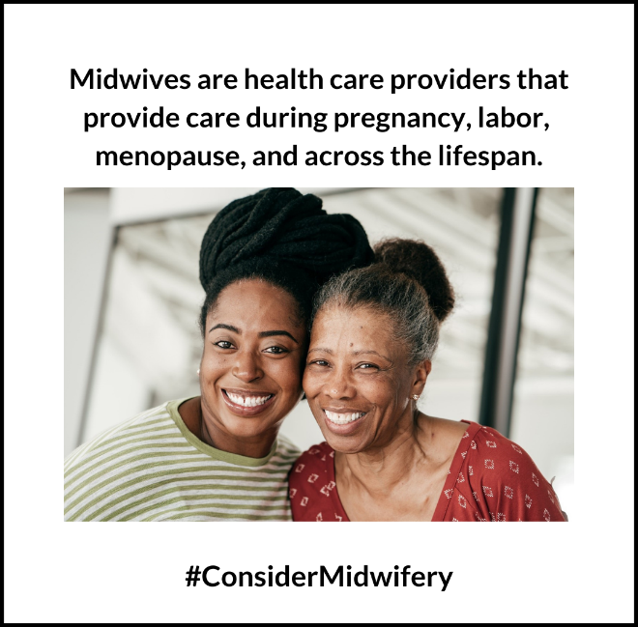
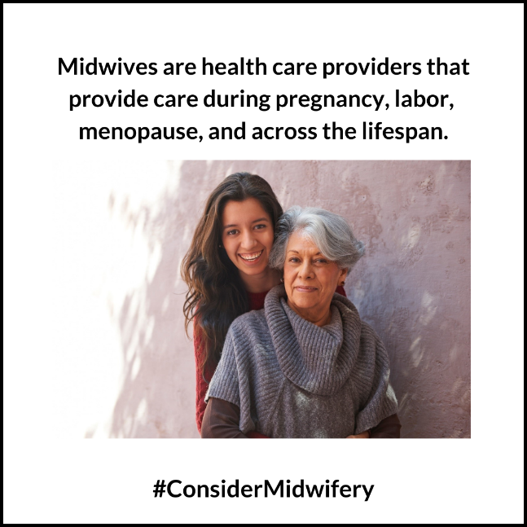

- Did you know midwives can provide all your reproductive health care needs? From annual check-ups to birth control counseling and services, they're here for you. Choose a provider that aligns with your values and preferences. #ConsiderMidwifery #ReproductiveHealth #MaternalHealth #MidwiferyCare
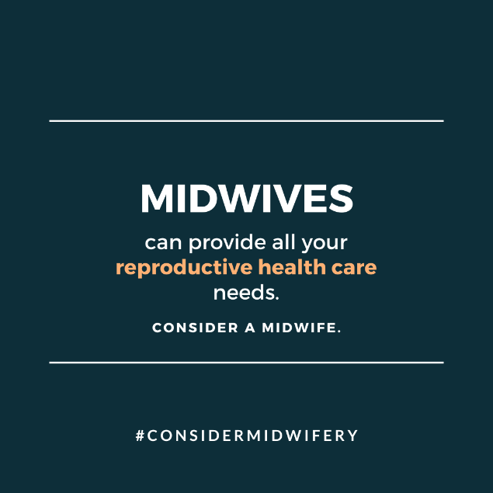

- Did you know that midwives and obstetricians work together to provide the best care for birthing people? Both can play crucial roles in ensuring a healthy birthing experience to support you every step of the way. Whichever professional you choose, rest assured you're in capable hands. #ConsiderMidwifery #MaternalHealth #Healthcare #Pregnancy #Births
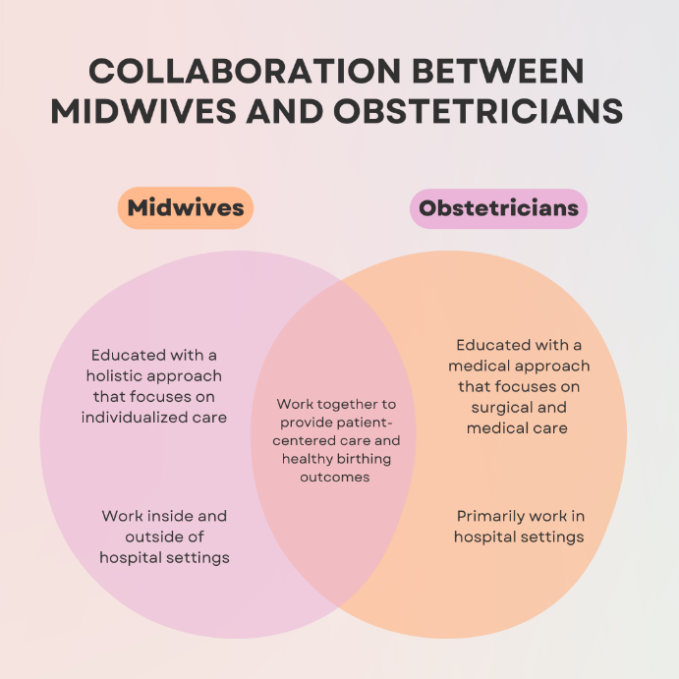

Additional Resources
Share Your Birthing Story with Midwifery Care on Social Media! 📣
Have you received care from a midwife during pregnancy, labor, or postpartum? Share your birth story online and use the hashtag #BirthJourneyStory to raise awareness around the necessity of midwifery care and how it made a difference in your childbirth experience.

Hospitals in New Jersey that Provide Midwifery Services:
To search for hospitals in New Jersey that provide midwifery services, please visit https://ratings.leapfroggroup.org/ and complete the following steps:
- Click “Certified Nurse-Midwives for Delivery” under the Maternity Care tab.
- Click “yes” to only show facilities near you.
- Click “any distance” and enter “New Jersey” in the search bar.
Note: updated information can be found by directly contacting a hospital’s obstetrics department.

For additional resources on midwifery practice, please refer to the following sources:
- The New Jersey Health Care Quality Institute and Burke Foundation’s Delivering Better Care: Midwifery Practice in New Jersey report: https://njhcqi.info/MidwiferyReport062022
- The Maternal Infant Health Hub’s resource page: https://njhcqi.info/MIHHub.

