SOCIAL MEDIA TOOLKIT

Midwifery for Policymakers: #PrioritizeMidwifery
Call to Action
The term “midwife,” (mi·dwife) originates from old English, meaning with woman. Midwives are health care providers that support pregnancy, childbirth, and the postpartum period, and also provide reproductive and primary health care at every life stage, including routine gynecologic care, annual exams, family planning services, and contraception education. Midwives utilize the midwifery model of care, which is a philosophy that views pregnancy and childbirth as normal life events and emphasizes person-centered care.
Although midwives are an essential part of the health care workforce, their work is often misunderstood, underused, and undervalued. The United States has the highest maternal mortality rates of any high-income country. In New Jersey, a Black woman is seven times more likely to die of pregnancy or birth issues than a white woman, and a Black baby is three times more likely than a white baby to die before his or her first birthday. Midwives have a key role in eliminating the state’s intolerable disparities.
This toolkit provides strategic language and sample social media posts to help raise policymakers’ awareness of the importance of midwifery to New Jersey families. We want to help you in your work to persuade elected officials and other decisionmakers to champion midwifery. Among our goals is legislation to expand the use of midwives and make the profession more sustainable by removing barriers to practice and enacting measures that support midwifery.
Instructions: This toolkit contains key messages, social media posts, graphics, and an email/newsletter text that promotes midwifery messaging to policymakers. Please share this content through your social media platforms and tag the New Jersey Health Care Quality Institute and the Burke Foundation in your advocacy efforts to support midwifery. You may also include your own social media handles, graphics, and hashtags as you customize each message to your liking. Together, let’s #PrioritizeMidwifery.
Key Messages for Policymakers
- Midwives improve health: Research associates midwife-led care with lower rates of cesarean sections, episiotomies, and inductions; reduced rates of preterm birth; and increased rates of breastfeeding – all of which can lead to better overall health for birthing people and babies and save our health care system money. Policymakers should consider making midwifery services more available, to reduce unnecessary medical interventions and promote safer, more natural childbirth experiences.
- Midwives help reduce maternal health disparities: A legacy of institutional and structural racism that still causes problems today contributes to wide health disparities among Black and brown people. Midwives are well equipped to provide culturally-sensitive, community-based care that helps make health care more accessible and improves results. Policy-makers should support initiatives to promote diversity within the midwifery workforce and expand midwifery services in underserved areas.
- Midwives support women's autonomy and choice: Midwifery helps provide patient autonomy and choice – often overlooked principles of health care. Many women and birthing people prefer a more personalized, holistic approach to maternity care than what they received from traditional sources. To that aim, midwives involve patients in decision making and respect their choices during pregnancy, birth, postpartum, and across the lifespan. Policymakers should prioritize measures that empower people to make informed decisions about their birthing location and childbirth experiences, including the option to choose midwifery care as part of a broader spectrum of maternity, well-women, and reproductive-care services.
- Midwives need policy changes: Midwives offer holistic, patient-centered health care not only during childbirth but also throughout the lifespan -- from family planning and reproductive health to menopause support. State policies should promote equitable reimbursement, workforce diversity, and access to midwifery services, so people of any age can make informed choices about their health care.
- Midwives deserve equitable reimbursement: Insurance reimbursement for midwifery services should be the same as the rate for physician services. New Jersey Medicaid adheres to this principle and other payers should too. Research makes clear that midwifery-led maternity care is associated with lower rates of such interventions as cesarean sections and inductions, leading to reduced health care costs. Prioritizing equitable reimbursement for midwifery services from all types of insurance will help control health care spending and improve care.
- Midwives have the right to fair pay: Equitably compensating midwives for their services would recognize the diverse needs of women and birthing people during their lifespan and maternity journey. Eliminating pay gaps would acknowledge that obstetrics and midwifery complement each other, providing a spectrum of care options that meet women’s individual needs. Fair compensation for midwives also would contribute to safer, more personalized inclusive, safe, and respectful maternity care across settings -- including at birth centers and in the home.
Social Media Campaign
Handles:
- Twitter & Facebook:
  - @NJHCQI
  - @BurkeFoundation
- LinkedIn:
  - @New Jersey Health Care Quality Institute
  - @The Burke Foundation
- Instagram:
  - @the_quality_institute_nj

Hashtags (If you would like to include):
#PrioritizeMidwifery, #MidwivesMatter, #MaternalHealth, #Midwifery #Midwife #Midwives #MidwifeServices #Pregnancy #Labor #Births #Birthing #NewJersey #NJ #ReproductiveHealth #WomensHealth #HealthPolicy
Website to Drive Traffic:
https://njhcqi.info/MIHHub

This social media kit contains sample posts you can easily customize, as well as images for you to include in your posts.
- Let's #PrioritizeMidwifery in state policies to improve maternity and reproductive care! Midwives address maternal health disparities, reduce unneeded interventions, and support healthy pregnancies and births. It's time for all pregnant people and babies to get safe, supportive, high-quality care. #MaternalHealth #HealthPolicy #WomensHealth #ReproductiveHealth #Healthcare
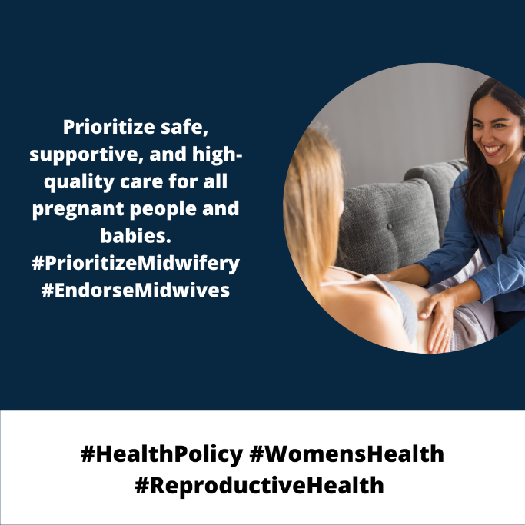

- Promote autonomy for childbearing people! State lawmakers should #PrioritizeMidwifery as a vital option. Midwives respect autonomy, support healthy births, and improve outcomes. Let's work together for inclusive, patient-centered maternity care. #MaternalHealth #HealthPolicy #WomensHealth #ReproductiveHealth #Healthcare

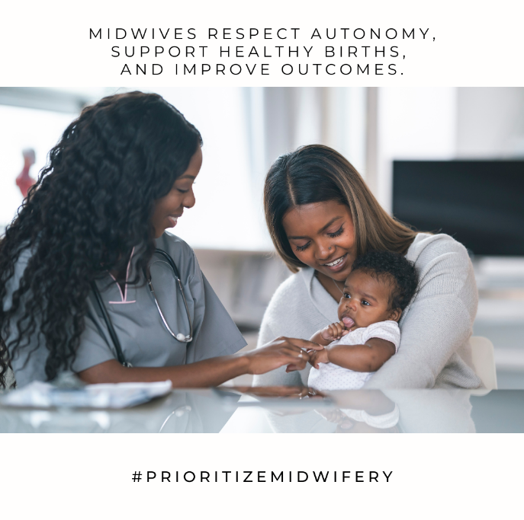

- For a better future for NJ families, #PrioritizeMidwifery in state policies. Let's build a midwife workforce to enhance care quality, reduce disparities, and bring safe, personalized birthing experiences to all. #MaternalHealth #HealthPolicy #MidwivesImproveOutcomes #ReduceDisparities #Healthcare
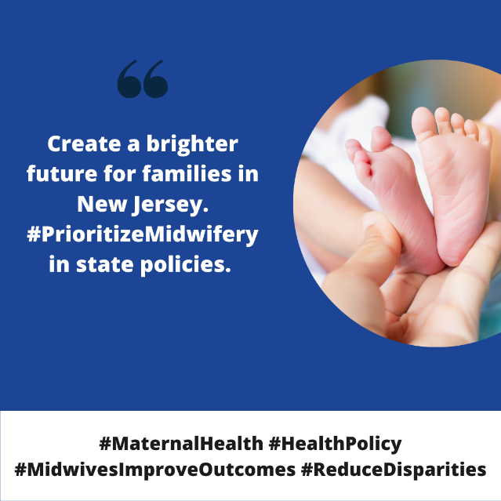

- Midwives provide health care across the lifespan -- not just during pregnancy and birth! From menarche through menopause, to family planning, preconception, and gynecological visits, midwives offer comprehensive, compassionate, personalized care. #PrioritizeMidwifery in state policies to promote pay equity, and culturally-congruent access to midwives. #MaternalHealth #HealthPolicy #WomensHealth #ReproductiveHealth #Healthcare

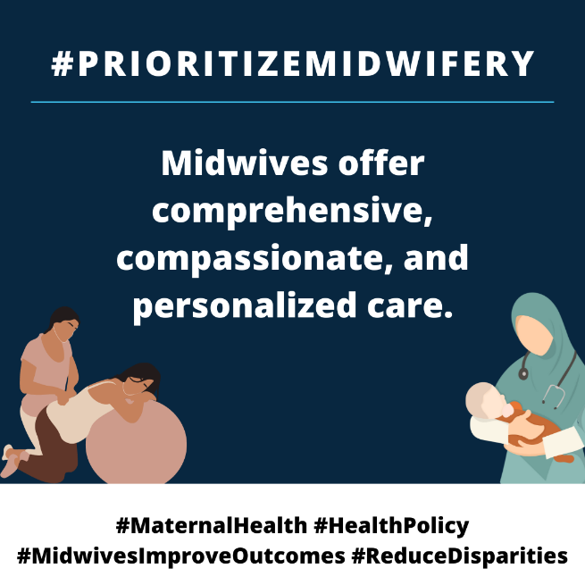

- Diversifying the diverse #midwifery workforce will help reduce health disparities in NJ. According @AMCBmidwife, only 7% of US midwives identify as Black & 5% as Latino. Read @NJHCQI & @BurkeFoundation report for recommendations to diversify the #midwifery profession: https://njhcqi.info/MidwiferyReport062022
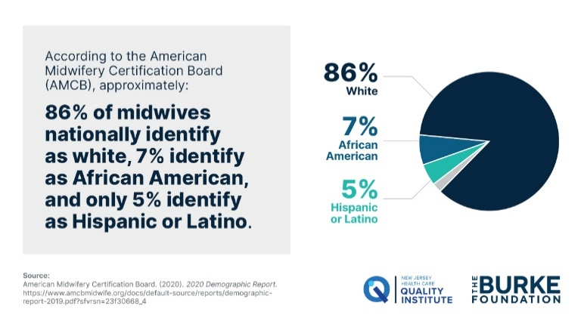

- Midwives and obstetrician gynecologists are trained, medical professionals that support pregnancy and childbirth using different models of care. Together, both professionals provide comprehensive services for birthing people and may work together to ensure healthy and safe outcomes.

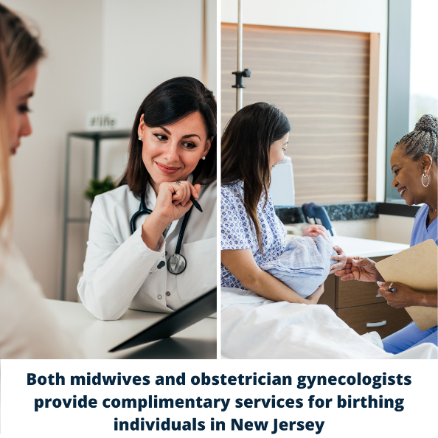

- Doulas are non-clinical professionals that provide physical, emotional, and educational support throughout the perinatal period. Doulas help create birth plans, advocate for patients, and partner with midwives to improve birth outcomes.
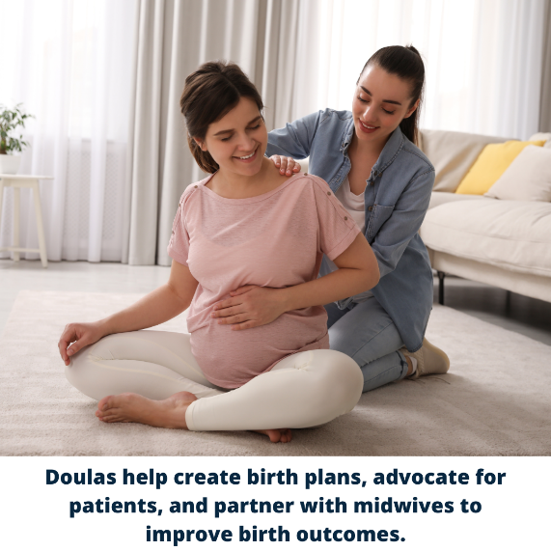

Newsletter/Email Text:
More birthing people will get the care they need if we eliminate barriers to midwifery practice.
New Jersey has only 409 practicing midwives; they attend fewer than 10% of births in the state. These midwives provide care in such settings as private practice, hospitals, outpatient clinics, freestanding birth centers, and the home.
Research makes clear that midwives help reduce health care disparities by providing culturally-congruent care aligning with patients’ language, values, beliefs, worldview, and practices. Despite the clear benefits of midwifery care, New Jersey regulations limit them from contributing more to the goal of making New Jersey the safest place to have a baby.
State policies should recognize the value of midwifery through equitable reimbursement, workforce diversity, and increased patient access to services -- so everyone can make informed health care choices. Recognizing the key roles midwives have in women's health, maternal health, and reproductive health will make high-quality care more inclusive and affordable for all.

Additional Graphics for Social Media:
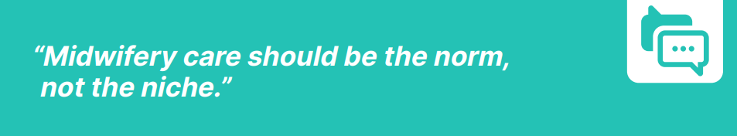
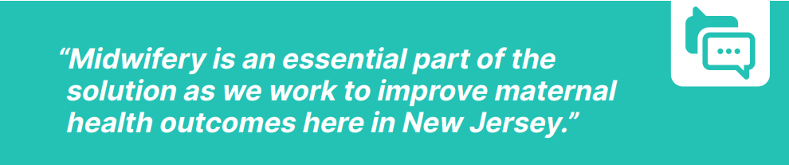
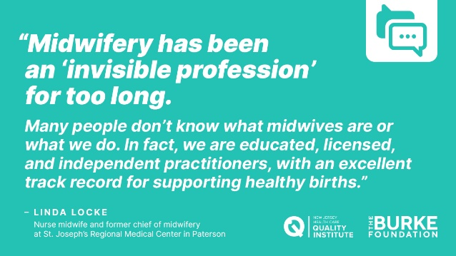

Additional Resources
For additional resources on midwifery practice, please refer to the following sources:
- The Quality Institute and Burke Foundation’s Delivering Better Care: Midwifery Practice in New Jersey report: https://njhcqi.info/MidwiferyReport062022
- The Maternal Infant Health Hub’s resource page: https://njhcqi.info/MIHHub.
- Supporting Midwifery is the Answer to the Wicked Problems in Maternity Care
- Midwifery: An Executive Summary for the Lancet’s Series

