Let’s Talk Mental Health: Myth or Fact

Week 1
Let’s Talk Mental Health… 💭 Know the FACTS about mental health from our docs!
#NJHCQI #MWCNJ #mayorswellnesscampaign #MentalHealth #MentalHealthMatters #LetsTalk #saintclareshealth #aroundthecorner #aheadofthecurve #selfcare #selflove
Video 9: https://www.cyranoapp.media/msg/?q=709195c2-e366-11ed-9a1c-1230392c7b08

Week 2
Let’s Talk Mental Health… 💭 Know the FACTS about mental health from our docs!
#NJHCQI #MWCNJ #mayorswellnesscampaign #MentalHealth #MentalHealthMatters #LetsTalk #saintclareshealth #aroundthecorner #aheadofthecurve #selfcare #selflove
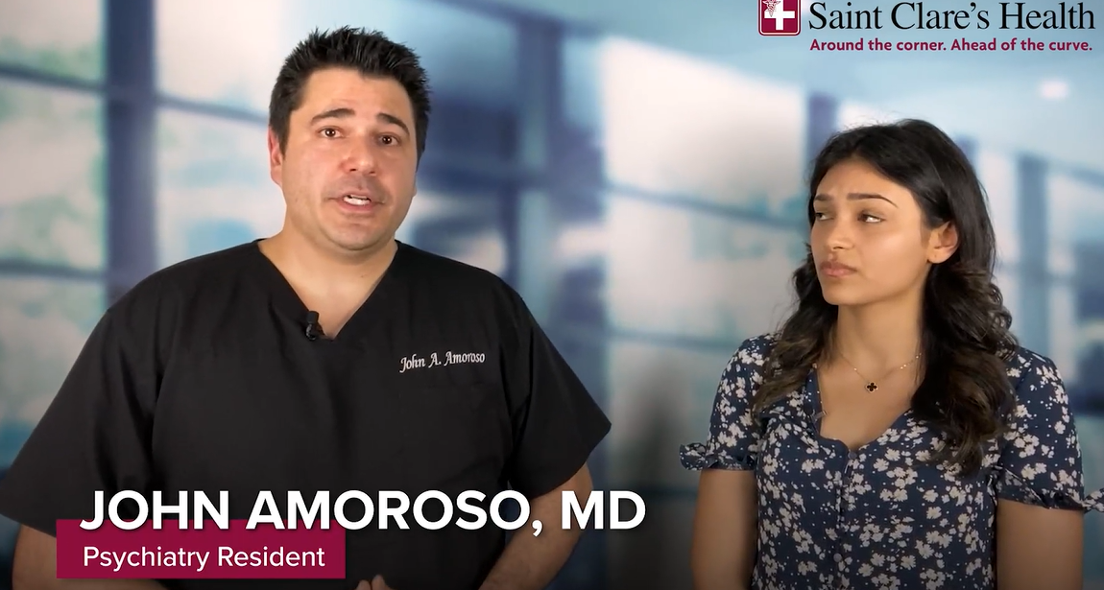
Video 7: https://www.cyranoapp.media/msg/?q=60fd8c31-e366-11ed-9a1c-1230392c7b08

Week 3
Let’s Talk Mental Health… 💭 Know the FACTS about mental health from our docs!
#NJHCQI #MWCNJ #mayorswellnesscampaign #MentalHealth #MentalHealthMatters #LetsTalk #saintclareshealth #aroundthecorner #aheadofthecurve #selfcare #selflove
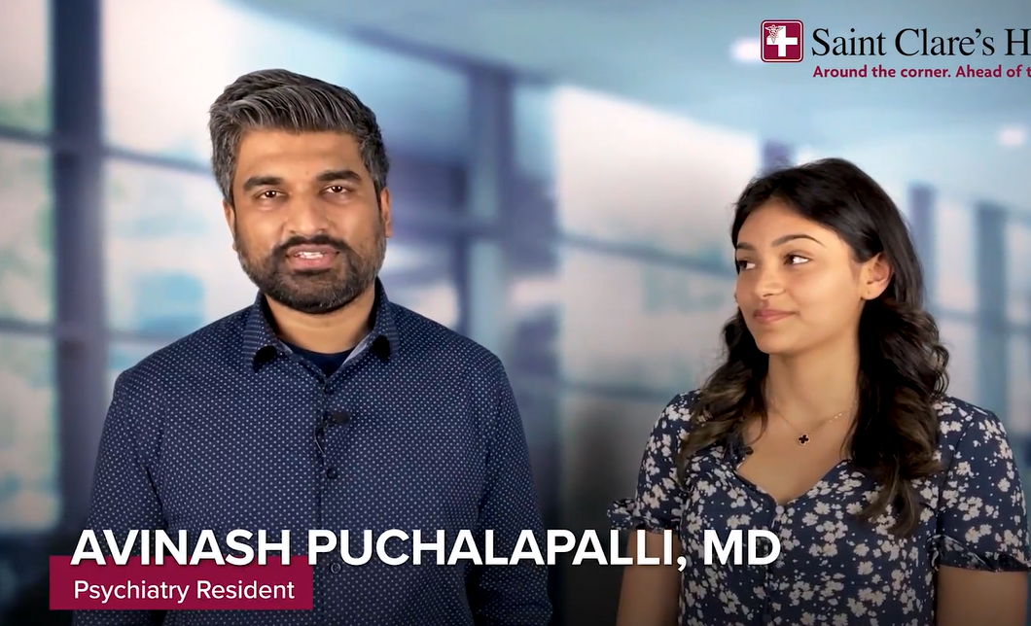
Video 1: https://www.cyranoapp.media/msg/?q=0d2db49e-e366-11ed-9a1c-1230392c7b08

Week 4
Let’s Talk Mental Health… 💭 Know the FACTS about mental health from our docs!
#NJHCQI #MWCNJ #mayorswellnesscampaign #MentalHealth #MentalHealthMatters #LetsTalk #saintclareshealth #aroundthecorner #aheadofthecurve #selfcare #selflove
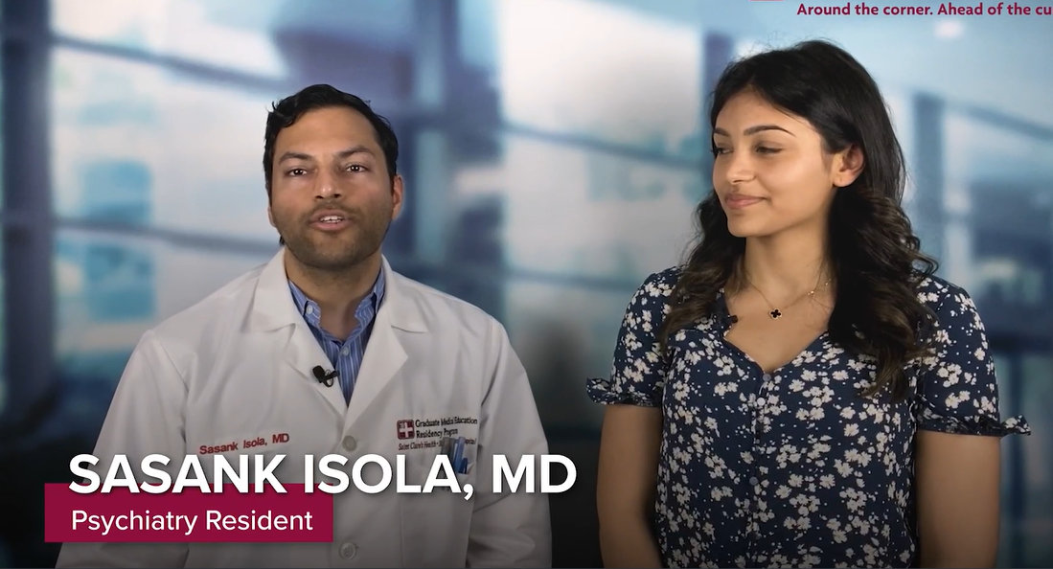
Video 4: https://www.cyranoapp.media/msg/?q=235e1863-e366-11ed-9a1c-1230392c7b08

Week 5
Let’s Talk Mental Health… 💭 Know the FACTS about mental health from our docs!
#NJHCQI #MWCNJ #mayorswellnesscampaign #MentalHealth #LetsTalk #saintclareshealth #aroundthecorner #aheadofthecurve #selfcare #selflove
Video 8: https://www.cyranoapp.media/msg/?q=6771ec09-e366-11ed-9a1c-1230392c7b08

Week 6
Let’s Talk Mental Health… 💭 Know the FACTS about mental health from our docs!
#NJHCQI #MWCNJ #mayorswellnesscampaign #MentalHealth #LetsTalk #saintclareshealth #aroundthecorner #aheadofthecurve #selfcare #selflove
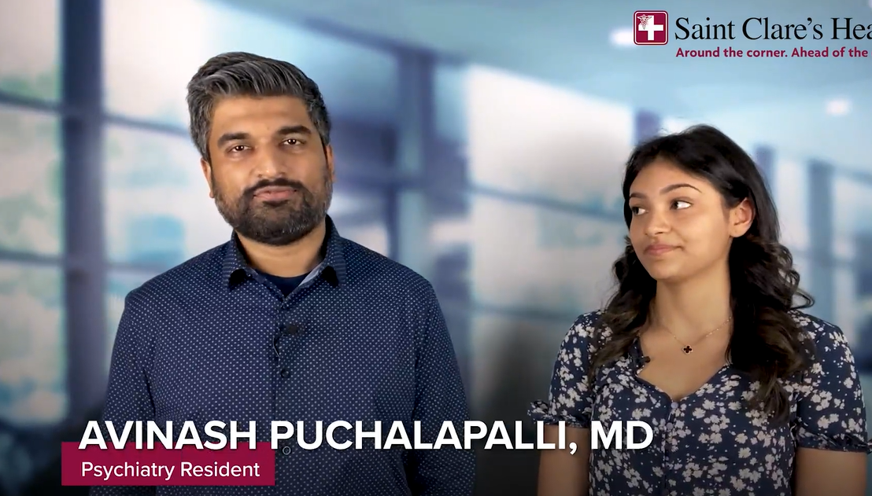
Video 2: https://www.cyranoapp.media/msg/?q=14b27305-e366-11ed-9a1c-1230392c7b08

Week 7
Let’s Talk Mental Health… 💭 Know the FACTS about mental health from our docs!
#NJHCQI #MWCNJ #mayorswellnesscampaign #MentalHealth #LetsTalk #saintclareshealth #aroundthecorner #aheadofthecurve #selfcare #selflove
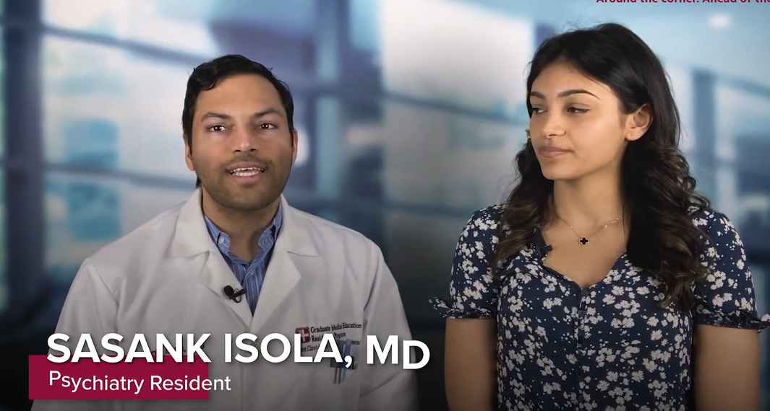
Video 5: https://www.cyranoapp.media/msg/?q=3c782e9c-e366-11ed-9a1c-1230392c7b08

Week 8
Let’s Talk Mental Health… 💭 Know the FACTS about mental health from our docs!
#NJHCQI #MWCNJ #mayorswellnesscampaign #MentalHealth #LetsTalk #saintclareshealth #aroundthecorner #aheadofthecurve #selfcare #selflove
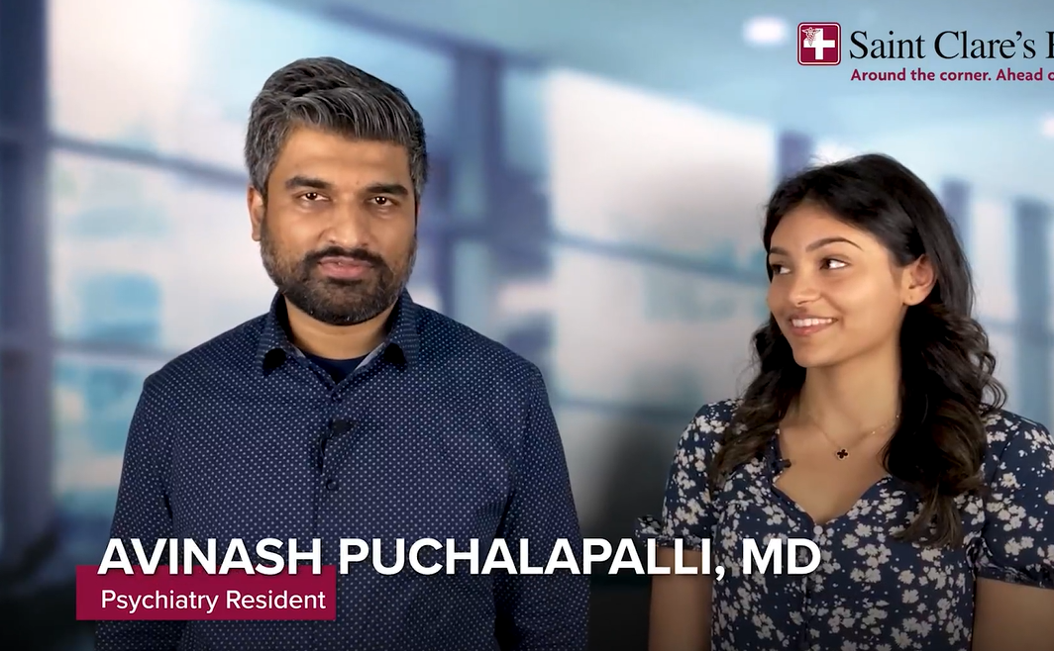
Video 3: https://www.cyranoapp.media/msg/?q=1c1a5a9c-e366-11ed-9a1c-1230392c7b08

Week 9
Let’s Talk Mental Health… 💭 Know the FACTS about mental health from our docs!
#NJHCQI #MWCNJ #mayorswellnesscampaign #MentalHealth #LetsTalk #saintclareshealth #aroundthecorner #aheadofthecurve #selfcare #selflove
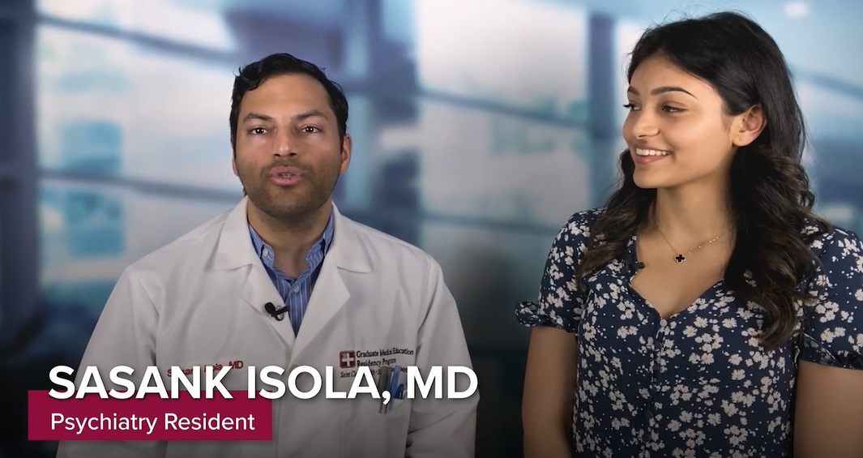
Video 6: https://www.cyranoapp.media/msg/?q=5986625a-e366-11ed-9a1c-1230392c7b08

