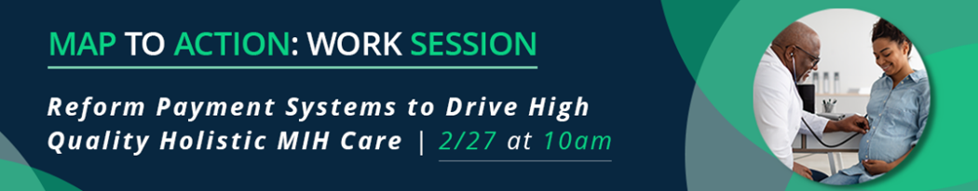

This session will focus on two themes that reflect the payment recommendations in the Maternity Action Plan (MAP):

MAP Recommendations | Work Session Theme and Discussion
- Support and sustain existing MIH programs and as needed, launch and leverage payment reforms and pilots to further MIH quality and equity. | Paying for Quality- Measuring impact of payment pilots and building long-term engagement; Support payment for quality outcomes and better care across payer lines of business
- Improve the Perinatal Risk Assessment (PRA) form and use it to connect pregnant individuals to social and clinical services. | Enhancing payment models for integrated care services through embedded behavioral and developmentally-supportive services- the HealthySteps model as an example.
- Build upon and scale existing care models that focus on the continuum of integrated care across the full perinatal period.

As you prepare for this session, and immediately after, please share the following with us:

Name and Organization:
Current and upcoming work on this topic:
We are interested in working on this topic: | ☐ Yes, as a participant  ☐ Yes, as a leader  ☐ Uncertain  ☐ No
To move this work forward, we need access to: | ☐ Other partners, including:  - Potential Partner  - Potential Partner  - Potential Partner  ☐ Convening and collaborating opportunities  ☐ Training and education  ☐ Funding: ______________________________________  ☐ Other: ________________________________________________

- File Save the completed document and email to bhanson@njhcqi.org

Your contributions to improving MIH across New Jersey are fundamental. Join us on Friday, March 3 for our in-person convening. Let’s continue today’s conversation and discover opportunities for collaboration between other key stakeholders in our state and nationwide.

