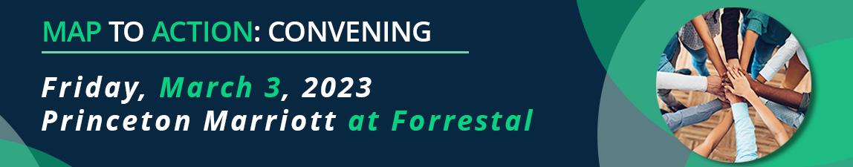

Name and Organization:
My goal for the Convening is to: | ☐ Share my work with partner organizations to move it forward  ☐ Learn about funding ideas/strategies  ☐ Learn about existing programs and how my organization can support or work with them  ☐ Other:_______________________________________________  _______________________________________________________
I/We are working on the following MAP Areas (check all that apply) | ☐ Data  ☐ Community Supports /SDOH  ☐ Workforce or Education  ☐ Payment Models/Reforms  ☐ Other __________________
Following the convening,  I want to work with others in the state, or will continue my work, on: | Fill in:

