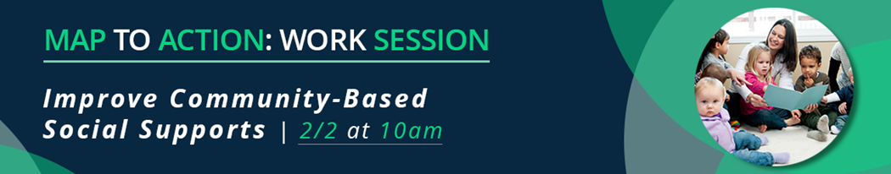

This session will focus on two themes that reflect the community-based support recommendations in the Maternity Action Plan (MAP):

MAP Recommendations | Work Session Theme and Discussion
- Make a safe, secure place to live available to all New Jersey families. | Engagement and investment in Medical Legal Partnerships to Support Client Access to Services
- Maximize financial support to families for high-quality childcare. | ConnectingNJ referral platform and embedding community programs during the full perinatal period; long-term funding for existing, evidence-based programs
- Enhance and build awareness of Connecting NJ to support Title V Block Grant and other community programs.

As you prepare for this session, and immediately after, please share the following with us:

Name and Organization:
Current and upcoming work on this topic:
We are interested in working on this topic: | ☐ Yes, as a participant  ☐ Yes, as a leader  ☐ Uncertain  ☐ No
To move this work forward, we need access to: | ☐ Other partners, including:  - Potential Partner  - Potential Partner  - Potential Partner  ☐ Convening and collaborating opportunities  ☐ Training and education  ☐ Funding: _________________________________  ☐ Other: ________________________________________________

- File Save the completed document and email to bhanson@njhcqi.org

Your contributions to improving MIH across New Jersey are fundamental. Join us on Friday, March 3 for our in-person convening. Let’s continue today’s conversation and discover opportunities for collaboration between other key stakeholders in our state and nationwide.

