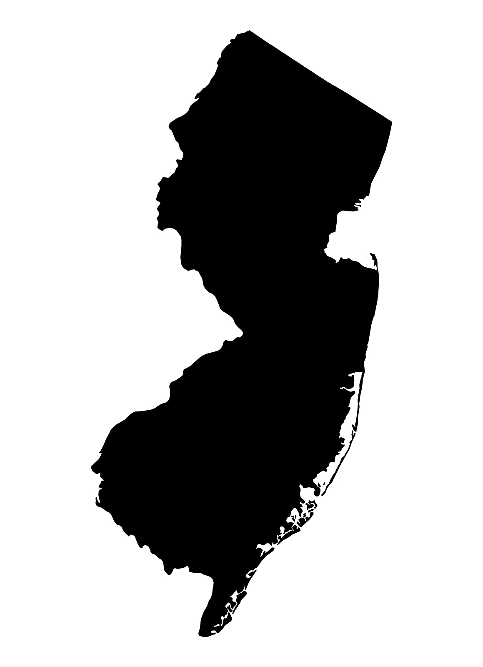
A Vision for a
Healthy New Jersey, One Town at a Time
Eat
Right
NJ!
How to create a successful and cost-effective wellness program for your town or city.

Creating an effective wellness program should very simple to implement and be focused on the elements that can have immediate and long-lasting impact on the greatest number of people. In many cases, wellness programs include well-intentioned activities that reach a very small percentage of the population and therefore have little widespread value.

We’d like to talk with you about a bold, fresh and innovative approach that makes this whole process much simpler to envision and execute.

Through our personal experiences, five years of research, conversations with dozens of nutrition and public health experts and surveys of kids and teens, we have learned that excessive and unhealthy eating and drinking habits are the drivers of obesity, which leads to a wide range of medical conditions and behavioral issues in people of all ages. Kids and teens are being diagnosed every day with “adult” illnesses like Type 2 Diabetes, high blood pressure, fatty liver disease and sleep apnea.

Therefore, the focus of a wellness program must be helping every resident of your town or city develop a strong desire to eat healthy and avoid junk foods, drinks and ingredients. Parents, kids, grandparents and caregivers need to be educated, motivated and empowered to WANT to eat healthy. Motivation is the key component and that’s where our program excels.

Who We Are

Nancy Lessner is a medical nutritionist who has helped over 2,500 families with weight related issues in her 20 year career. With two advanced degrees, experience in working in hospital and private practice, and having developed a school nutritional program, she brings a wealth of proven experiences to our company, Eat Right LLC.

Irv Brechner is a strategic marketer and author of 18 books, including five on weight loss and healthy eating. He is a prolific writer and content developer, and with Nancy, created “Eat Right NJ!”

Our Program

We have created a flexible and customizable multi-media program for municipalities that includes seven compelling and inspiring videos, posters, charts and lists in both English and Spanish. Combined with a letter from the Mayor and mailed to every household, this program has the potential to positively impact large numbers of people quickly and with long-lasting results. Towns and cities can select from a large library of printed items and include their own brochures and flyers for health-related services. To learn more about this innovative approach, call us today:

Irv Brechner, President
Eat Right LLC
732-321-1924 | Irv@NancyLessner.com

The rest of this overview contains the elements of our program, what people are saying about it, and ideas for funding and more. “Rachel’s Story” shows how educating and motivating one child led to her family developing healthy eating habits, saving money and reversing potential serious disease.

The Eat Right NJ! Program includes:

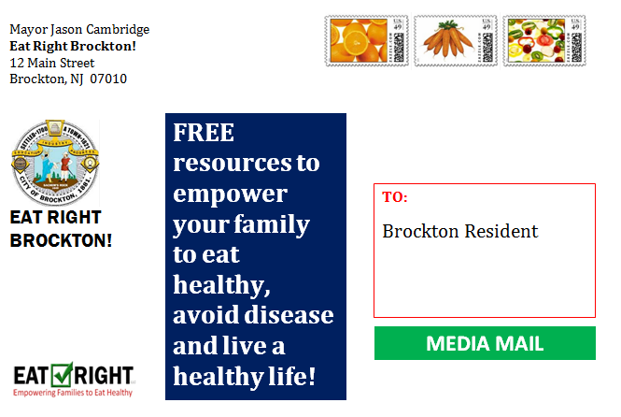
Each household receives a box with a powerful message on a colorful label indicating the contents. It is mailed via inexpensive Media Mail.

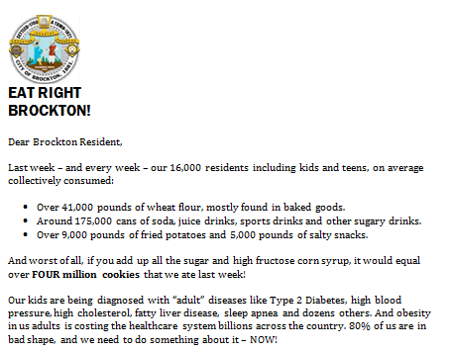
The first item in the box is a letter from the mayor that talks about the announcement of the “Eat Right [YourTown]!” program and why it’s so important.

The package includes a DVD, and five or more other printed pieces, which can be customized and personalized based on the needs of your town, and if appropriate, a sponsor’s flyer. All items can include the municipality’s logo and a sponsor logo as well.

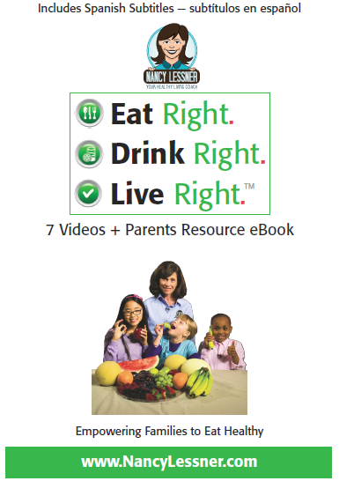
The “Eat Right. Drink Right. Live Right” DVD contains 7 videos in English and 7 in English with Spanish sub-titles:

- How Much Sugar Kids and Teens Eat
- Good and Bad Fast Food
- The Best and Worst Snacks
- How to Read Nutrition Facts Labels
- 79 Reasons to Eat Healthy
- 20 Great Habits of Healthy Eaters
- The Family That’s Doing It Right!

Also on the DVD is the Parents Resource eBook in English and Spanish, including:

- 40 Great Reasons to Lose Weight
- 46 Diseases Caused or Impacted by Obesity
- 25 Strategies for Healthy Eating at Home

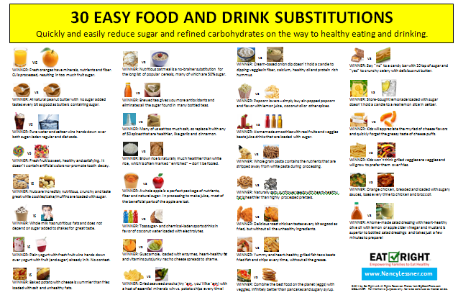
This poster, designed to be hung on the fridge or pantry closet door, gives the family simple and easy food and drink substitutions with brief explanations of why they are so important for healthy eating and drinking.
All posters, lists and charts are available in English and Spanish and can be translated into other languages.
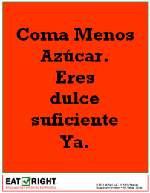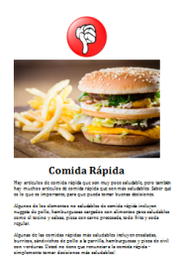

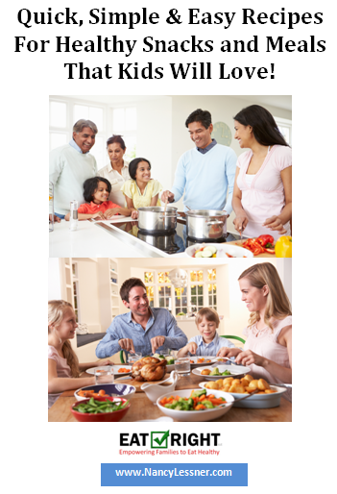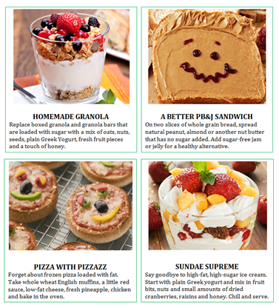
Delicious recipes for healthy snacks and meals that kids, teens and even adults love.

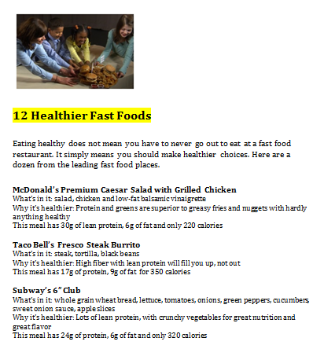
12 healthier alternatives to unhealthy fast food. Families don’t have to stop going to fast food restaurants, just make better choices!

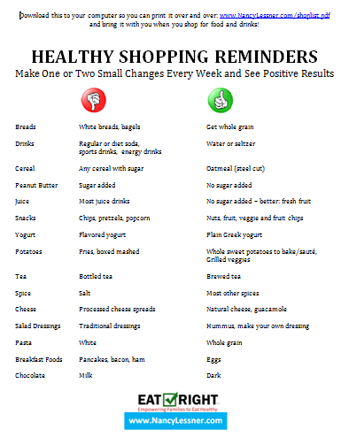
A handy reminder list that you can take to the supermarket – reminders of healthy foods and drinks to buy, and unhealthy ones to avoid.

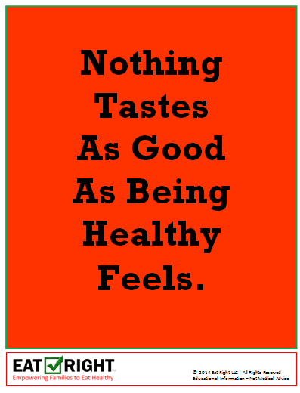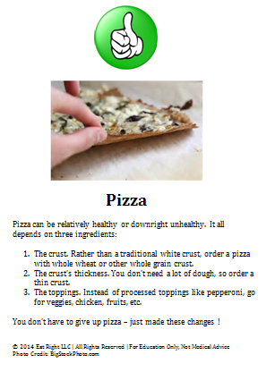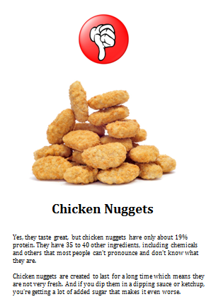
Motivational posters from our library. All printed items can be mixed and matched as desired.

We can also provide all of our posters in bulk so that towns and cities can hang them in store windows, offices, government buildings, etc. as constant reminders of the importance of eating healthy.

Other Uses

Any of these items are available for events, lectures, workshops, etc. We can do live eye-opening demonstrations at your events as well.

Funding

A municipality may elect to fund this project directly or look to one or more sponsors to cover some or all of the cost of DVD duplication, printing and mailing services. We can provide you with a strategic approach should you need to find sponsor(s) for this project.

Specialty Programs

In addition to our program for municipalities, we have developed programs for:

- Hospitals
- Schools
- Organizations serving youth (i.e. Big Brothers Big Sisters, Boys & Girls Clubs)
- Businesses and Corporations

What People Are Saying

“The videos are compelling. A local nutritionist has produced eye-popping videos that teach youngsters how to eat healthy.” (Cheryl Wills, NY1 Award-Winning Anchor, Long-Time Health Reporter)

“I think these videos will make a huge impact on anyone that watches them, young and old.” (Carol Hartwell, mom of 11-year old Ariana)

“There's been a lot of discussion around our dinner table since Dominic did the shoot! We no longer have chicken nuggets in our home and had fun as a family researching healthy recipes to make them ourselves. We ALWAYS have kale chips and almond butter in the cabinet now. And my 9 yr old foster daughter refused a cool aid type drink at her visit with her birth mom recently. Huge impact!” (Leslie Serra, mother of Dominic who appeared in “The Best and Worst Snacks” video)

Rachel’s Story: Family Heroine

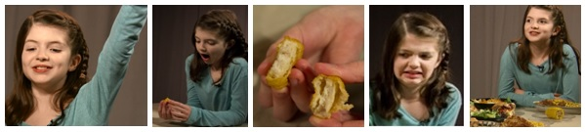
Rachel is a 10-year old girl who went from loving chicken nuggets and fries to no longer eating them for over 8 months as the immediate result of one of our videos. Her strong desire to eat healthy spread to her family. Here’s what happened.

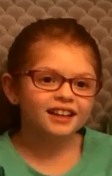
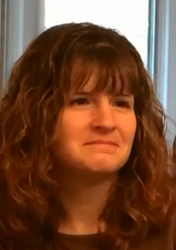
See and hear the family’s story in their own words: https://vimeo.com/115523245 (password: rs)

Sarah, 7
- Embraced fruits, veggies and eating healthy and avoids junk food.
- Is keenly aware of all the sugar and chemicals in foods and drinks.
- Asks for yummy broccoli and string beans instead of fries, loves strawberries.
- “We stopped eating fast food. When we go by the [fast food] place, we say ‘eeeeeeewwwwww.’”
Miriam (mom)
- Enjoying cooking and preparing healthy meals and snacks for her family.
- Convinced schools to make major healthy menu changes that the kids love.
- She has a lot less to worry about now that the family is healthy.
- “It’s really inexpensive to eat healthy. It’s been a real eye-opener for all of us.”
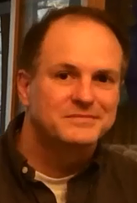
Larry (dad)
- Lost 30 pounds and numerous serious medical conditions disappeared.
- Before the video, unhealthy eating habits due to work pressures, stress eater.
- After the video, he’s become highly educated about foods, drinks and ingredients and the need to consistently make healthy choices.
- “Rachel’s interest after the video [shoot] made me really think about what I was eating. Our family has come a long way since then.”
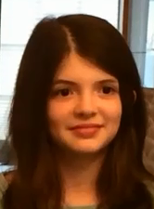
Rachel, 10
- Stopped eating chicken nuggets and fries after learning about the unhealthy ingredients in fast food.
- Feels healthier, sleeping better, has more energy and made the soccer team.
- Vitamin D levels returned to normal after changing eating habits.
- “I shared what I learned with my family and friends, and they made healthier choices. I’m really proud of myself!”

